**WEBD-1000**

*Coding Challenge 6 JSON*

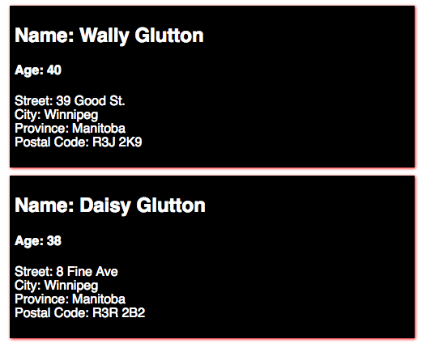

Using the files [provided here](https://drive.google.com/open?id=1M7_ma2plVVu8CLYl7s8xWvpb_sDvk0Qo), complete the for loop to output JSON into the HTML page.

Use template literals and expressions where necessary, and the ***Object.values()*** method to get all the address information.

The <h2> is for the name. The <h4> is for the age. The <p> is for the address information. After completion these need to be added to the <section> element.

Note that the address information is added to the paragraph; add a <br /> after each entry of the address.

When done let your instructor know and they will grade your work.